Complex differentiability
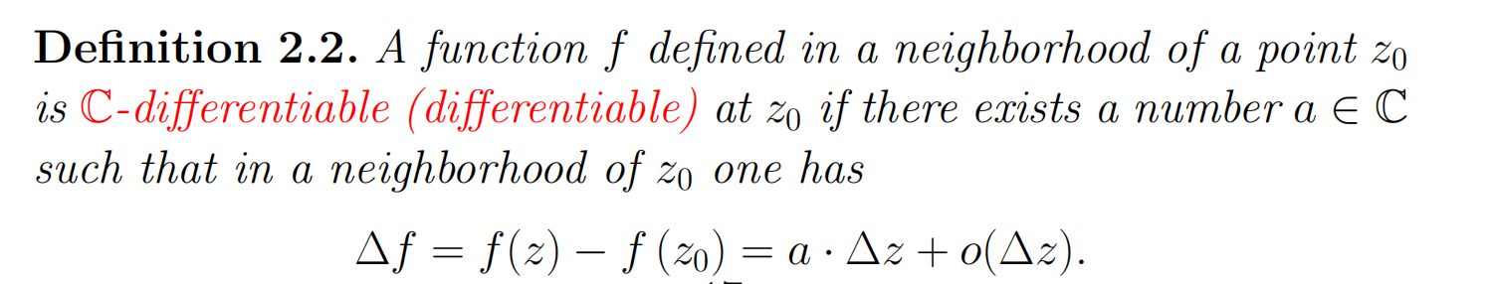
Elementary functions of complex variable
P20-26
Cauchy-Riemann identity
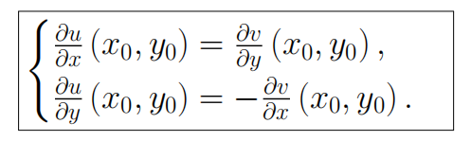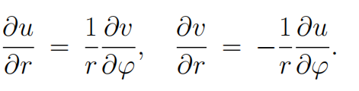
Complex logarithm
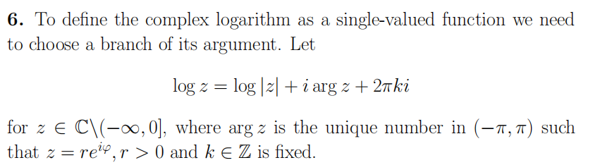
Holomorphic function
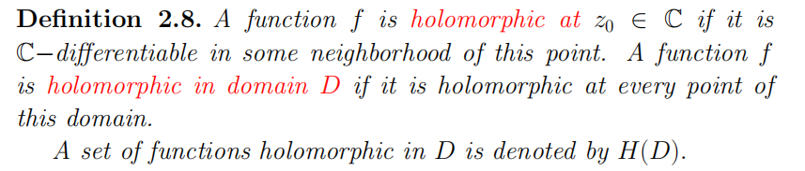
Conformal map
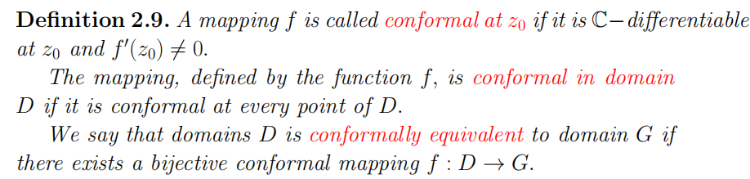
Cauchy-Goursat’s Theorem
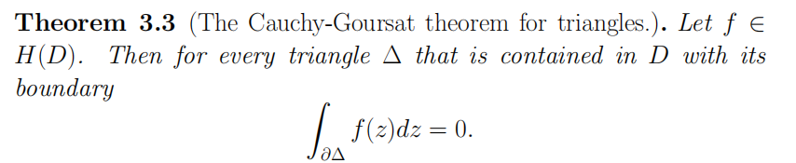
Antiderivative
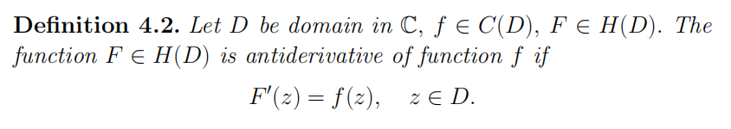
Antiderivative along path
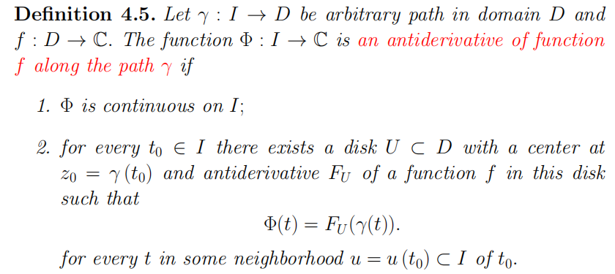
Homotopy
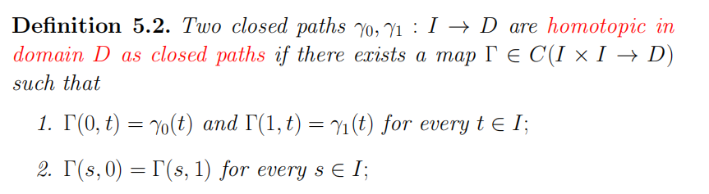
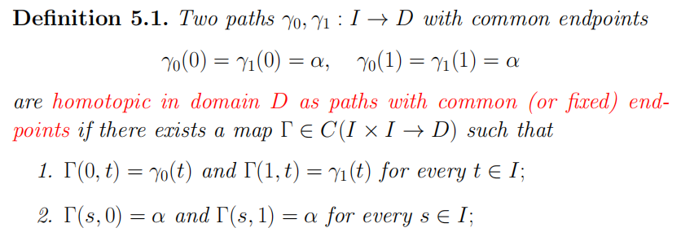
Cauchy’s integral
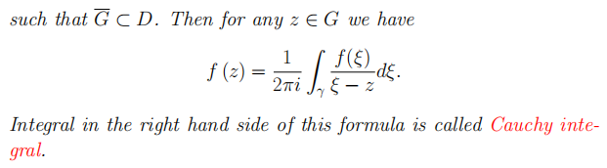
Taylor’s series Laurent’s series
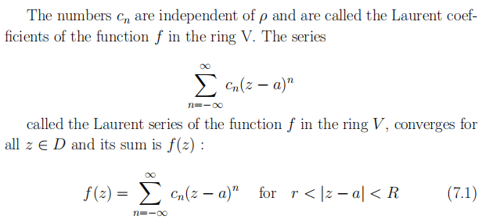
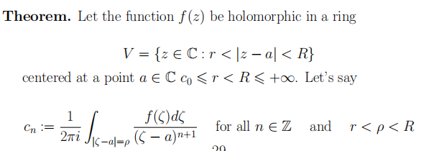
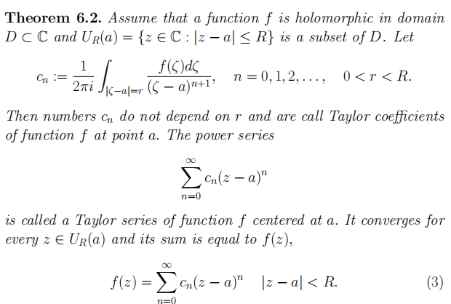
Maximum modulus principle
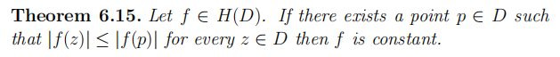
Types of isolated singular points
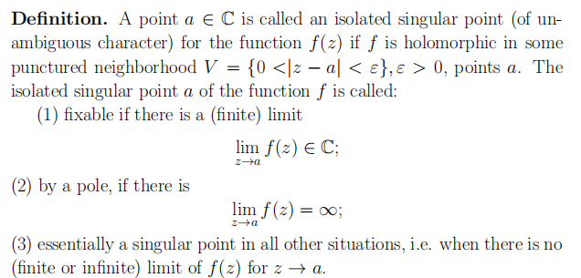
Integer function
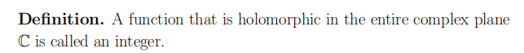
Residue
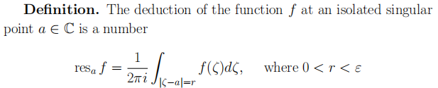
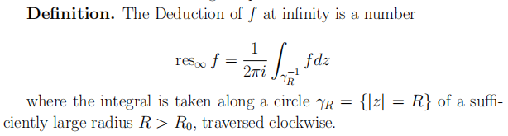
Residue theorem
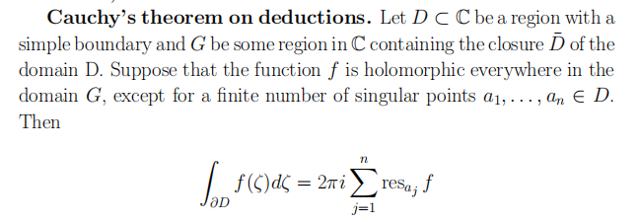
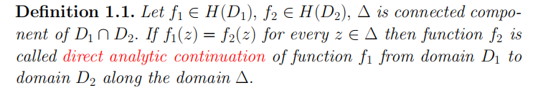
Analytic continuation
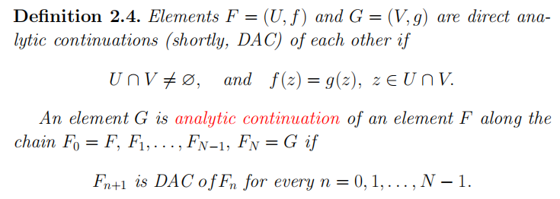
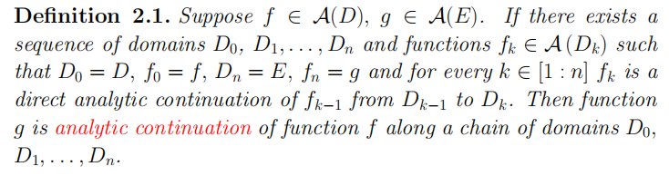

Analytic continuation along path
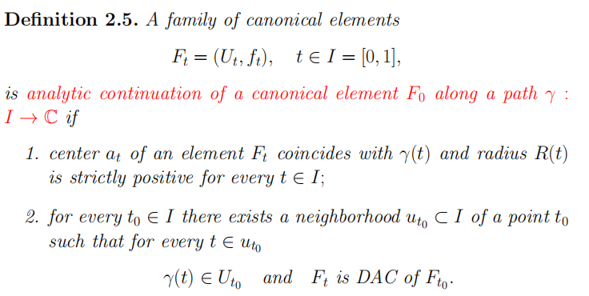
Analytic function(1st definition)
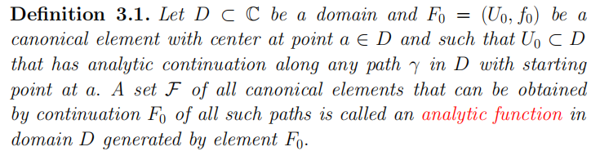
Germ of analytic function
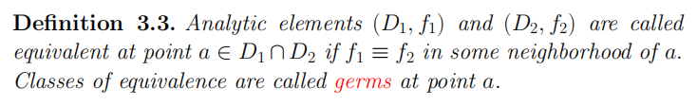

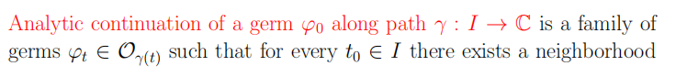

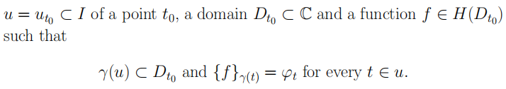

有名字性质和定理
Riemann sphere

Cauchy-Riemann Identity

De’Moivre Formula

Harmonic function

Cauchy-Goursat(triangle, contractible path,multiple-connected domain)

Newton-Leibniz Formula

Cauchy (on homotopy)

Cauchy Integral Formula

Cauchy Integral Formula for derivatives

Cauchy inequality(Taylor&Laurent)

Liuville

Morer

Maximum modulus principle

Sokhotsky

Residue theorem

Jordan lemma

Argument principle

Rouche

Gamma-function

Monodromy theorem

